Data Analysis
Introduction:
The Students Course Completion Analysis project aims to analyze student enrollment and course completion data. This project helps in understanding how many students complete their courses and how completion rates vary across different courses. The analysis provides useful insights to improve course effectiveness and student performance.
Objective:
The objective of this data analysis project is to analyze student learning behavior, course engagement, progress tracking, payment patterns, and platform usage using structured data from multiple tables.
This analysis helps in understanding student performance, course effectiveness, retention patterns, and overall system efficiency to support data-driven academic and business decisions.
Scope of the Project:
This project analyzes student enrollment and course completion data. It identifies course completion rates and learning trends. The analysis helps improve course planning.
Dataset Description:
The dataset contains information related to students, courses, and course completion status. It includes details such as student ID, course ID, enrollment date, and completion status. This data is used to analyze course completion patterns and student performance
Tools and Technologies Used:
- MySQL – for storing, querying data and analysis.
- Python – for data analysis and visualization.
Pandas & Matplotlib – for data processing and charts, plots, graphs.
- PowerPoint – for data presentation and reporting.
- MS Excel
- Draw.io
Data Cleaning:
Missing values were handled using Python. Invalid data types were corrected, duplicates removed, and foreign key mappings applied.

Analyses Based on Available Tables:
Student Analysis (students table)
● Identify total number of students city-wise.
● Analyze student distribution based on gender and employment status.
● Identify age-wise distribution of students.
Course Analysis (courses table)
● Identify total number of courses category-wise.
● Analyze course distribution by course level.
● Identify courses based on duration and instructor rating.
Enrollment Analysis (enrollments table)
● Identify total enrollments course-wise.
● Analyze enrollment trends over time using enrollment_date.
● Analyze completion status distribution (Completed / In Progress / Dropped).
● Identify preferred payment modes during enrollment.
Student Progress & Performance Analysis (progress_matrix table)
● Analyze student distribution based on education level.
● Identify students with highest and lowest progress percentage.
● Analyze impact of quiz attempts, quiz scores, and assignments on course progress.
● Evaluate student performance using project grades and time spent.
● Analyze peer interaction and rewatch behavior in relation to progress.
App Usage & Learning Engagement (app_ussage table)
● Analyze student engagement using app usage percentage.
● Identify preferred device types used by students.
● Analyze effect of internet quality on video completion rates.
Payment & Revenue Analysis (payments table)
● Calculate total revenue generated from all payments.
● Analyze revenue distribution based on payment modes.
● Identify impact of discount usage on payment completion status.
● Compare payment completion status with course completion status.
Support & Satisfaction Analysis (support_tickets table)
● Analyze student satisfaction based on support ratings.
● Identify number of students raising support tickets.
● Analyze relationship between support tickets and course progress.
Login & Engagement Analysis (login table)
● Analyze login frequency of students.
● Identify inactive students based on days since last login.
● Correlate login frequency with student progress and completion status.
SQL Analysis
SQL queries were used to analyze student enrollment, course completion status, completion rates, and course-wise performance. The analysis helped identify total enrollments, completed courses, and overall learning trends across different courses.
Dataset Overview: The dataset consists of three main tables:
Students: - Contains information about students, including student ID, name, email, education level, and enrollment details.
CREATE TABLE students (
student_id VARCHAR(100) PRIMARY KEY,
student_name VARCHAR(100),
gender VARCHAR(20),
age INT,
city VARCHAR(100),
employment_status VARCHAR(100)
);

Courses:- Contains details about the courses offered, including course ID, course name, course duration, and course fees.
CREATE TABLE courses (
course_id VARCHAR(50) PRIMARY KEY,
course_name VARCHAR(100),
category VARCHAR(50),
course_level VARCHAR(50),
course_duration_days INT,
instructor_rating FLOAT
);

Enrollments (course_completion):- Captures information about student course enrollments, including enrollment ID, student ID, course ID, enrollment date, and course completion status.
CREATE TABLE enrollments (
enrollment_id INT AUTO_INCREMENT PRIMARY KEY,
student_id VARCHAR(50),
course_id VARCHAR(20),
enrollment_date DATE,
payment_mode VARCHAR(50),
fee_paid VARCHAR(10),
discount_used VARCHAR(10),
completion_status VARCHAR(50)
);
Step to be perform:
Database Connectivity: To perform the analysis, we'll establish a connection to the MySQL database containing the ecommerce data. We'll use the appropriate Python libraries, such as pandas and mysql, to fetch and manipulate the data directly from the database.
# Example Python code for connecting to MySQL database using
mysql-connector-python
import mysql.connector
import pandas as pd
import numpy as np
# Replace 'your_username', 'your_password', 'your_host', and 'your_database' with actual credentials
connection = mysql.connector.connect(
host="localhost",
user="root",
password="1234",
database="students_course_analysis"
)
# Create a cursor object to execute SQL queries
cursor = connection.cursor()
# Query data from the 'students' table
students_sql = """
INSERT IGNORE INTO students
(student_id, student_name, gender, age, city, employment_status)
VALUES (%s, %s, %s, %s, %s, %s)
# Query data from the 'course' table
cursor.execute(
"""
INSERT INTO courses
(course_id, course_name, category, course_level,
course_duration_days, instructor_rating)
VALUES (%s, %s, %s, %s, %s, %s)
""",
(row["course_id"],row["course_name"],
row["category"],row["course_level"],
row["course_duration_days"],
row["instructor_rating"]
)
)
cursor.execute(
"""INSERT INTO enrollments
(student_id, course_id, enrollment_date, payment_mode, fee_paid, discount_used, completion_status)
VALUES (%s, %s, %s, %s, %s, %s, %s)""",
(row["student_id"],row["course_id"],row["enrollment_date"],row["payment_mode"],row["fee_paid"],row["discount_used"],row["completion_status"]))

Python Analysis
Python was used for advanced aggregations, visualizations, and exporting clean datasets for Power BI and Excel usage.
Output:
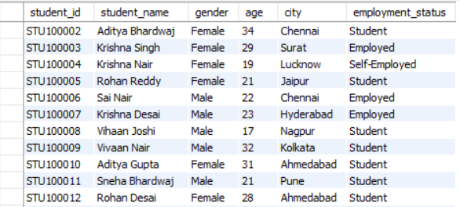

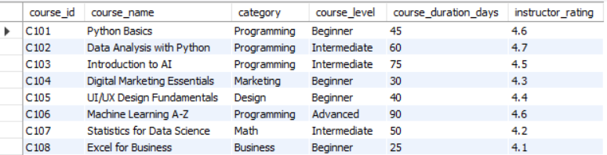

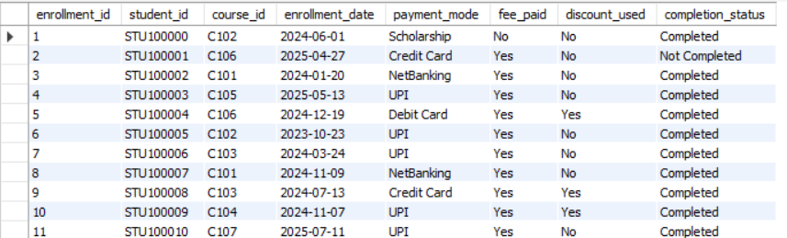

Description:
students_df=pd.read_csv("C:\\DANLC labs\\Course_Completion_Analysis\\students_data.csv")
pd.DataFrame(...): This part creates a Pandas DataFrame using the pd.DataFrame() constructor. It takes the fetched data (result of the query) and the list of column names as arguments. The DataFrame is assigned to the variable students.
In summary, this line of code fetches data from a database using a cursor, extracts column names from the cursor description, and creates a Pandas DataFrame with the fetched data and column names. The resulting DataFrame (students) can be used for further analysis or manipulation using Pandas functionalities.
Data Cleaning:
Before proceeding with the analysis, let's perform some basic data cleaning:
● Check for missing values in each table.
● Ensure data types are appropriate for each column.
● Handle any outliers or in consistencies.
Exploratory Data Analysis (EDA) and Visualization: Analysis of Total Student by Gender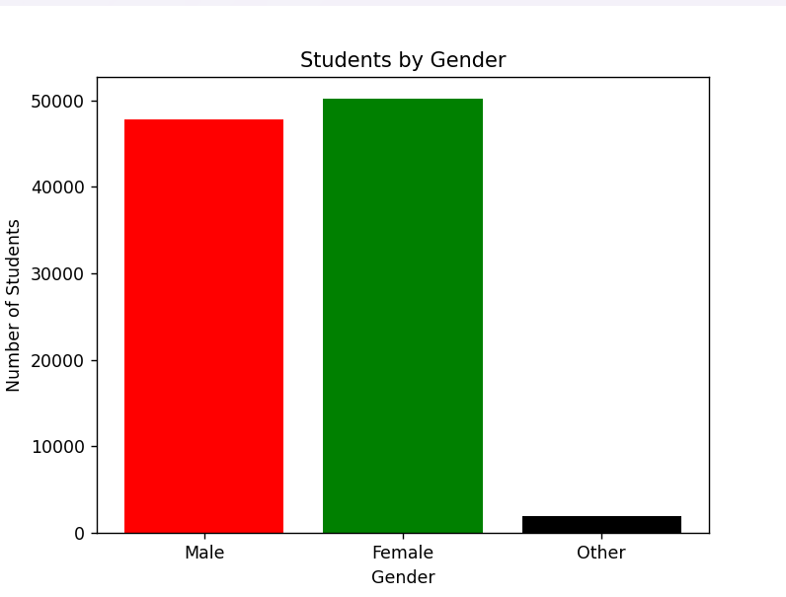

Analysis of Students by City-wise
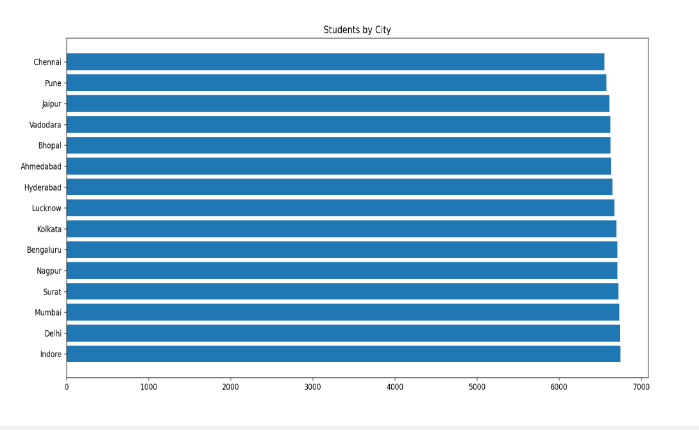
Analysis of Employment status
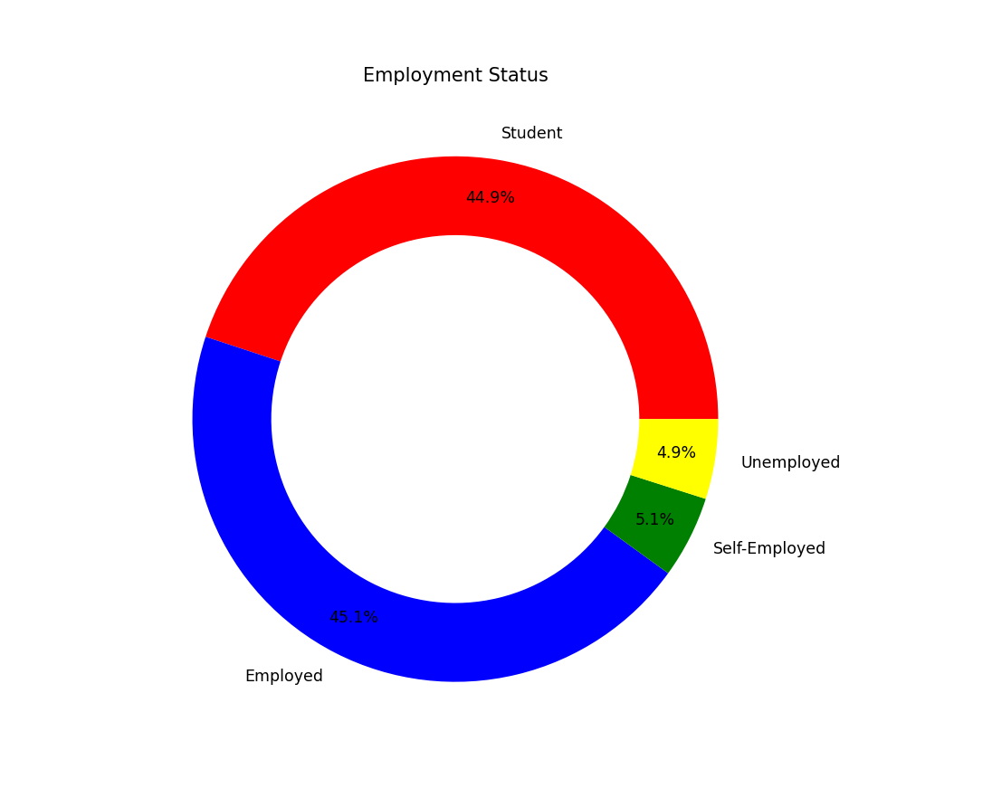
Analysis of Enrollment per Course
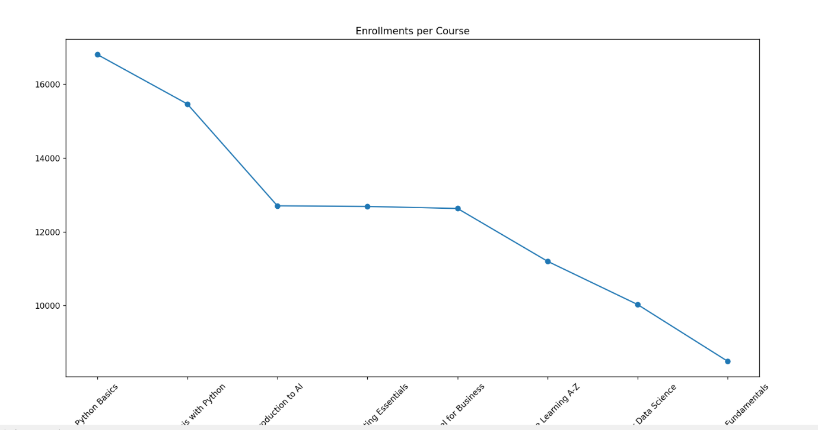

Analysis of Students course completion status
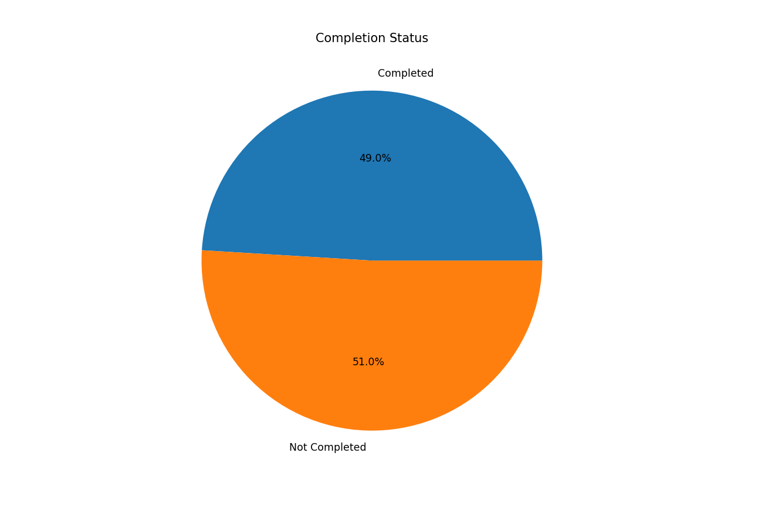

Course Analysis:
Students course discount usage distribution
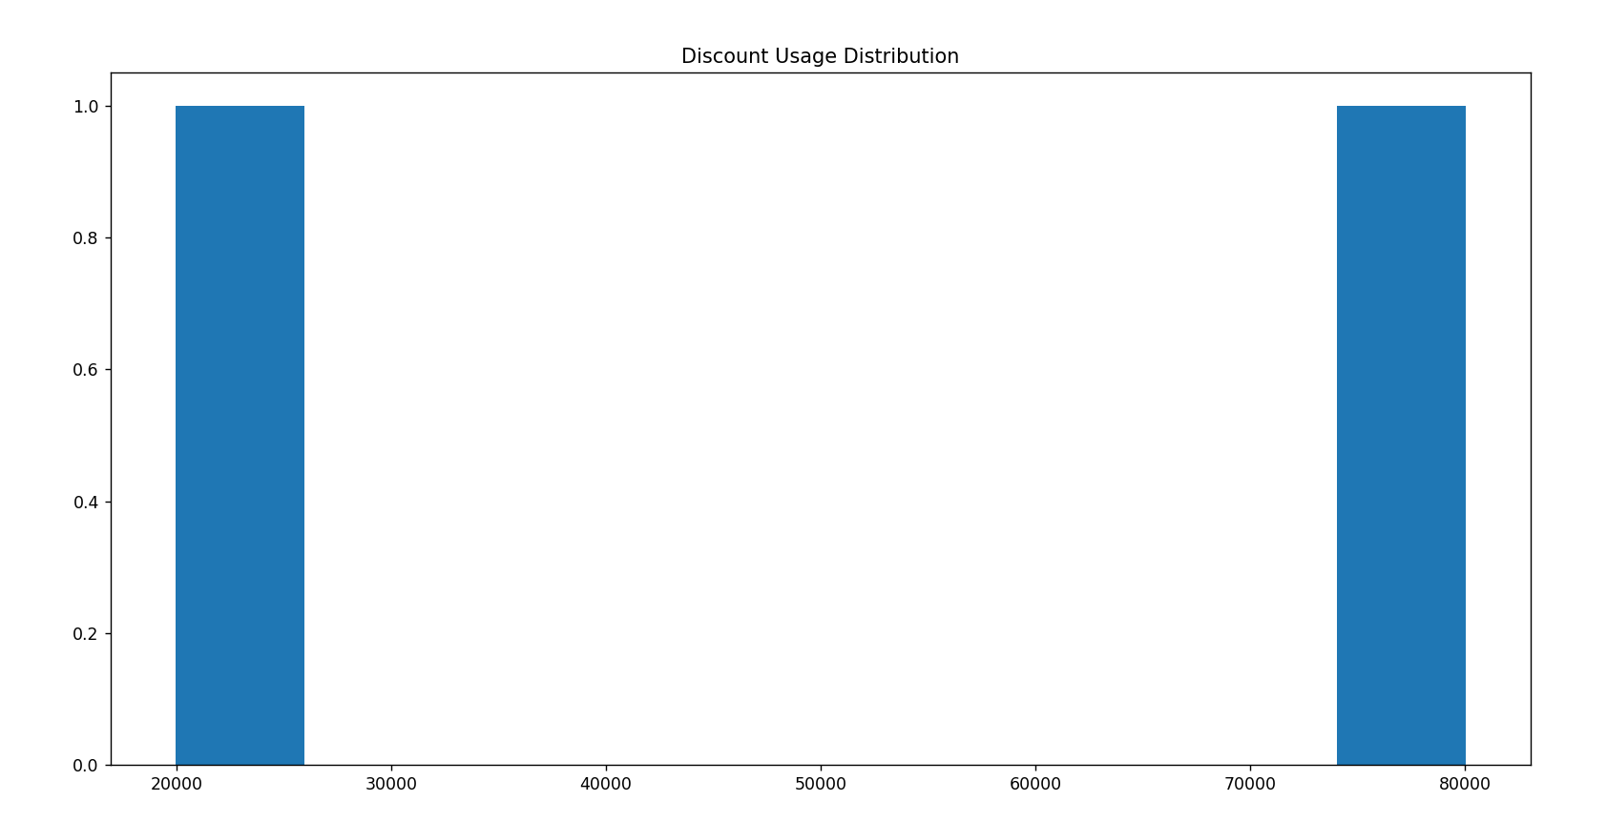

Top 5 popular courses
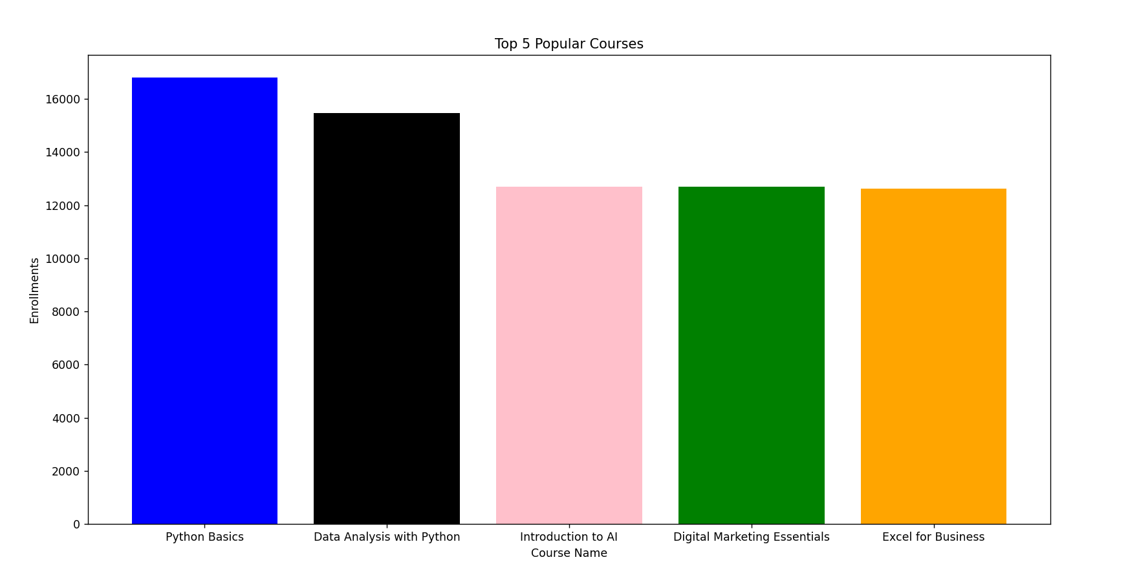

Payment Analysis:
Students payments mode usages
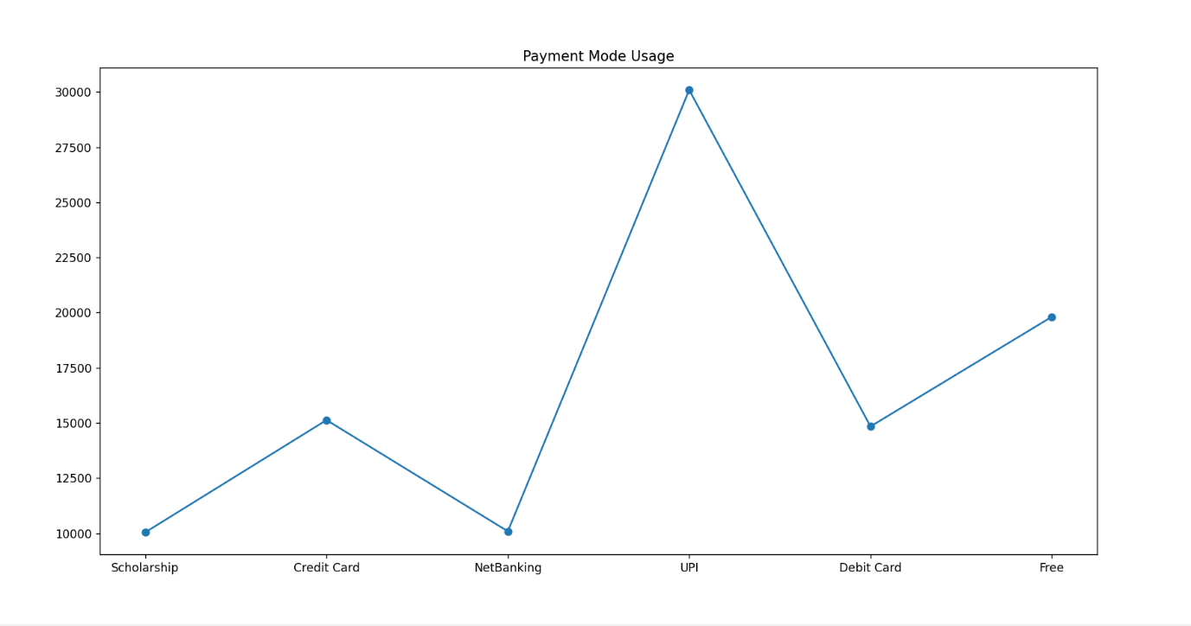
ER Diagram: The ER diagram represents the relationship between students, courses, and enrollments in the system. It shows how students enroll in courses and track their course completion status. The diagram helps in understanding the database structure and data flow clearly.
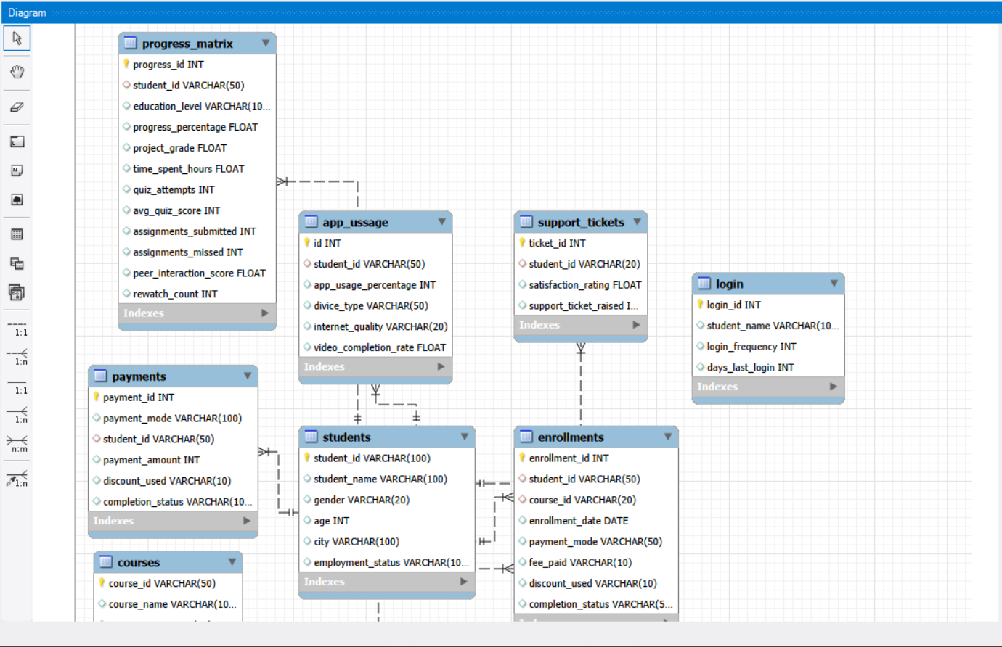
Power BI Dashboard
Interactive dashboards were created including KPIs, slicers, team analysis, player performance, and match insights.
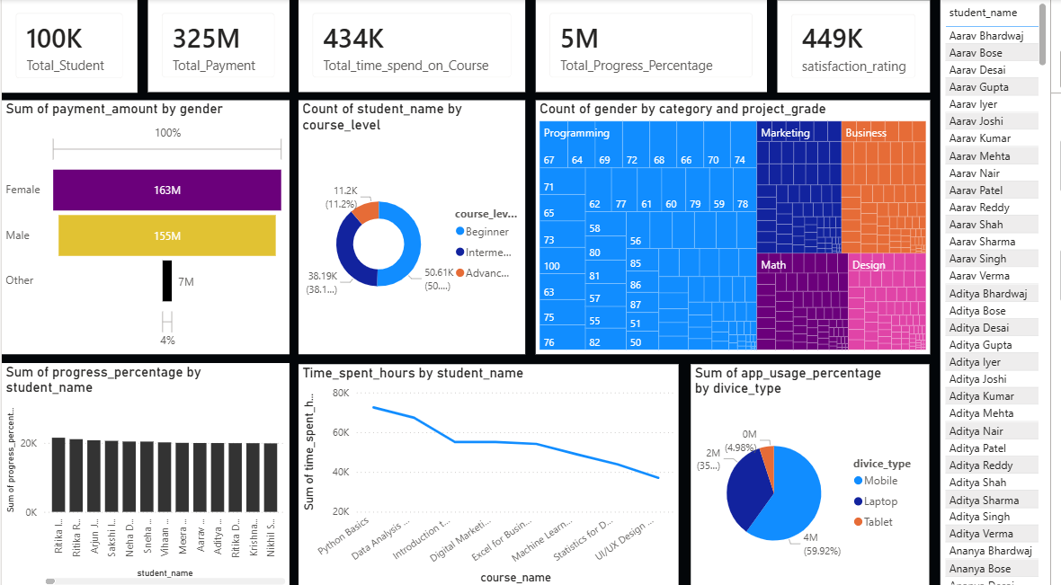

Conclusion
The Students Course Completion Analysis project provides valuable insights into student enrollment and course completion patterns. The analysis helps understand course performance and supports better academic planning and improvement.
Future Work / Enhancements
In the future, more parameters such as student performance scores and feedback can be added to the dataset. Advanced analytics and dashboards can be used for better visualization. Predictive analysis can also be implemented to identify students at risk of non-completion.

